Application for 2023 COGGO Research Funding

The Application process for the 2023 COGGO Research Fund will be conducted in two stages:
Stage 1
Expression of Interest (EOI).
Submission of an EOI is designed to enable applicants to outline their project to determine if it is eligible and likely to be competitive in terms of the criteria used to evaluate project proposals in Stage 2. Stage 1 EOI’s should be no more than three pages. Once you have submitted your EOI you will be contacted by the Coordinator for the COGGO Research Fund by email or phone to discuss your proposed project to determine its eligibility and COGGO interest in funding. Stage 1 EOI’s can be submitted anytime but must be emailed to GIWA by no later than 5pm on Friday 1st July 2022.

Email your Expression of Interest Application to coggoresearchfund@giwa.org.au
or mail to: COGGO Research Fund, GIWA, PO Box 1081, Bentley DC, WA 6983
Grower Group presentations.
Grower groups (and some others) submitting EOI’s may be requested to come and present their proposal to a special COGGO Board meeting. Depending on the outcome of this pitch the Board may invite the Grower Group to proceed to submit a full proposal. This “Shark Tank” like session will be held in Perth and if your group is invited to attend you will be offered $500 to help offset the cost of travelling to Perth to present.
Stage 2
Applicants submitting an EOI, whether asked to present to the Board or not, will be advised if their EOI is successful by email and invited to progress to Stage 2 and submit a project proposal which will be due by 5pm WST on Monday 29th August, 2022.
Criteria used to evaluate Project Proposals in Stage 2
COGGO funding criteria | If you are invited to submit a Full Project Proposal this is how your application will be assessed.
MAIN CRITERIA
A. Potential benefit to WA grain growers (including discussion of the likely length of time before the results can be applied or adopted).
B. What is innovative about the project*
C. Potential for a commercial return to COGGO (Is there an avenue for the research to be commercialised for the mutual financial benefit of the researcher and COGGO
Other CONSIDERATIONS
D. Likelihood of achieving the outcome (Why is the approach likely to succeed? Is adoption of the innovation practical? How are any impediments to adoption to be addressed?).
E. Value for money (cost of project to COGGO versus expected value of outcomes, amount of co-investment in cash or in-kind).
F. Key personnel (include key personnel and their track record of achievement in this area, also any capacity building of less experienced staff/contractors)

Important qualifications
COGGO will give preference to fund research and development projects that qualify as R&D projects under Division 355-B of the Income Tax Assessment Act (ITAA97) with the following definition of Core R&D activities:
“experimental activities whose outcome cannot be known or determined in advance of the basis of current knowledge, information or experience, but can only be determined by applying a systematic progression of work that:
- is based on principles of established science; and
- proceeds from hypothesis to experiment, observation and evaluation, and leads to logical conclusions.
Core activities are conducted for the purpose of generating new knowledge (including new knowledge in the form of new or improved materials, products, devices, processes or services).”
COGGO will require a firm commitment in the Stage 2 Project Proposal as to its potential share of the IP, EPR’s or royalties of any project that is presented for funding.
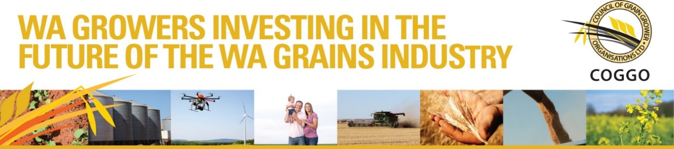

COGGO Research Fund 2023
Stage 1: Expression of Interest application (3 pages maximum)
Projects can be funded for no more than 2 years and to a maximum of $75,000 per annum, and a total of $150,000.
Project title
Name of Proponent
ACN/Legal Name or ABN
Mailing Address
Contact Person
Position
Telephone
Email
Proposed Commencement Date
Proposed Completion Date
Note: Projects are expected to run on a calendar year cycle but may be deferred, provide prior approval is sought, if there are reasons for a delay or seasonal conditions dictate a sensible postponement of the project to the next season.
Project Aim | Describe the AIM or OBJECTIVE of the project (i.e. what you intend the project to achieve and the potential benefit to WA grain growers)

Funding sought | Amount of COGGO funding sought and duration of project (1 or 2 years)

MAIN CRITERIA

What is innovative about the project?
How will success be measured? | What is the outcome if this project is successful?
Potential for a return to COGGO | Potential for a flow of royalties or other payments to COGGO from the project

Stage 1 EOI’s can be submitted anytime but must be emailed to GIWA at coggoresearchfund@giwa.org.au by no later than 5pm on Friday 1st July, 2022

